Forum: Human Rights Council
Issue: Safeguarding Rights of migrant workers
Student Officer: Ignacio Saravia
Position: Former President

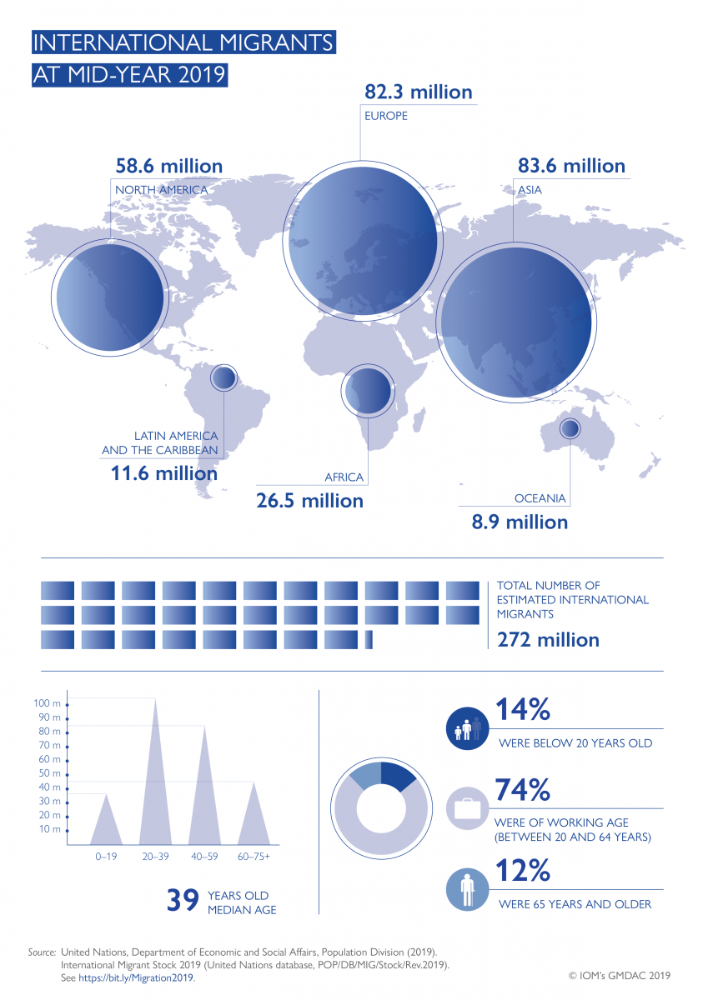
Introduction
Migrant workers suffer serious violations of their human rights, including ill-treatment by immigration or law enforcement authorities, abusive or exploitative working conditions, lack of basic workplace rights and protections, limited access to social security, systemic discrimination and wide-spread xenophobia and prejudice.
Migrant Workers are a vital part of the global economy, seeking opportunities in foreign countries under the promise of decent working and living conditions. Some citizens in Less Economically Developed Countries (LEDC’s) have little to no choice but to emigrate their country in search of other opportunities around the world, such as most Member States in Central and Latin America.
Immigration can enhance the cultural, economic, social, civil and political structures in the countries. The costs of labour migration can outweigh the benefits due to the fact that the rights of migrant workers are not protected in many countries, thus making them vulnerable to abuse by employers and government officials such as discrimination, hazardous working conditions, extortion, arbitrary detention, deportation and violence.
Women migrant workers are even more vulnerable because they do not only suffer from the previously mentioned abuses but they also suffer injustices of being women in a world that treats them like less. Factors contributing to systemic violations of human rights of migrant workers include negative public attitudes, language barriers, restrictive immigration regimes, poor legal protection, lack of awareness, weak rule of law and impunity.
Definition of Key Terms
Migration
The United Nations Migration Agency defines a migrant as: “any person who is moving or has moved across an international border or within a State away from his/her habitual place of residence, regardless of (1) the person’s legal status; (2) whether the movement is voluntary or involuntary; (3) what the causes for the movement are; or (4) what the length of the stay is.”

Xenophobia
The Office of the United Nations High Commissioner for Human Rights defines a manifestation of Xenophobia as: “Manifestations usually triggered by intense dislike or hatred against people that are perceived as outsiders, strangers or foreigners to a group, community or nation, based on their presumed or real descent, national, ethnic or social origin, race, colour, religion, gender, sexual orientation or other grounds.”

Issue Overview
Historical Background
Recruitment of international workers has been a common practice by developed countries such as the United States, having a raise in popularity during the 1920’s and 1930’s. The first migrant workers usually worked as farmers but, as industries appeared and grew, more workers were needed in the cities, so by the late 1960’s and onwards, migrant workers started going directly to the cities instead of working as farmers.
Underprivileged citizens are the most attracted to these offers, especially when it comes to living in these countries. However, some of these companies or agencies seeking to recruit international workers propose an unrealistic view of the reality of their work, sometimes resulting in the abuse and mistreatment of the workers, may it be physical or psychological.

According to an International Labour Organization's (ILO) report, there is an estimate of 164 million migrant workers worldwide distributed in the following way: 111.2 million (67.9 percent) are employed in high-income countries such as the United States or the United KIngdom, 30.5 million (18.6 percent) in upper middle-income countries like Argentina or Brazil, 16.6 million (10.1 percent) in lower middle- income countries such as the Phillipines and Bolivia and 5.6 million (3.4 percent) in low-income countries like Ethiopia or Mali.

Major Countries and Organizations Involved
- Global Migration Group (GMG): this organization is an inter-agency group that brings together heads of agencies with the aim to promote the application of relevant international and regional instruments and norms relating to migration. The GMG’s main concern and goal is to improve the effectiveness of its members and other stakeholders in responding to the challenges presented by international migration.
- International Organization for Migration (IOM): the IOM is a intergovernmental organization that aims to achieve a humane management of immigration throughout the world, by stimulating international cooperation on the matter, as well as aiding migrants in need.
- United Nations High Commissioner for Refugees (UNHCR): the UNHCR targets to secure asylum and safe refuge in a different Member State for every person that needs to. Moreover, they give emergency assistance to those that are being displaced, such as but not limited to clean water, shelter and healthcare.

Latest Events
ILO Report, Global Estimates on International Migrant Workers
On December 5th, 2018 the ILO released a report that stated an estimate of all migrant workers worldwide from 2013 to 2017 and classified them according to gender, age group, country of origin and country of residence. In the report there is also a comparison to previous statistics and a reflection on how this migration movement may affect the economic growth of the countries involved.
18/12/2019 Events
For last year’s International migrants day, the ILO and other organs from the UN held different events to commemorate migrant history and raise awareness on how migrant people are treated around the globe. These events happened in New York, United States and Bangkok, Thailand. The New York event was called “International Migrants Day 2019 Celebration and launch of the Manuel on Covering Migration in Media”, it was held on Wednesday 18 December 2019 from 2:30pm to 6pm at the United Nations Headquarters conference room 12. The event in Bangkok, Thailand was named “International Conference to Commemorate International Migrants Day”, held December 17 and 18 of 2019 at Chulalongkorn University.

Possible Solutions
Since the issue of the rights of migrant workers is widely international, it is very difficult to ensure its solution, in spite of all the numerous measures that have been applied. This is why the solutions proposed might seem unreachable to their entirety, seeing as they demand every Member State to implement them.
Firstly, it is of utmost importance that Member States include laws and regulations protecting the rights of all migrant workers, without exception, in order to establish a base for the solution of the issue. Another possible solution would be the creation courses that would train migrant workers in order to gain skills so as to work in reliable, safe jobs to enhance their quality of life. Migrants need to know their rights and it is of key relevance to instruct them in the laws of the country they are migrating to.
Furthermore, it would be ideal if Member States were to provide temporary asylum to migrants throughout the process of receiving their legal documents, who are left to their own means while their legality is ensured.

Useful reference material
ILO Global Estimates on International Migrant Workers – Results and Methodology
Promoting and Protecting the Rights of Migrant Workers: A Manual for NHRIs
Promoting and Protecting the Rights of Migrant Workers by the Asian Pacific Forum, ISBN 978-0-9873578-3-0.
Migration, human rights and governance

Bibliography
Promoting and protecting the rights of migrant workers (2020, January 6) Retrieved from https://www.asiapacificforum.net/support/training/migrant-workers/ .

Gafoor, A. F. A. (2019, December 20) Safeguard the rights of migrant workers. Retrieved from: https://www.thestar.com.my/opinion/letters/2019/12/20/safeguard-the-rights-of-migrant-workers.

UNHCR (2006, September 1) Global Migration Group. Retrieved from: https://www.unhcr.org/global-migration-group.htm

United Nations (n.d.) Migration. Retrieved from: https://www.un.org/en/sections/issues-depth/migration/index.html

International Labour Organization (2018, December 5). New ILO figures show 164 million people are migrant workers. Retrieved from: https://www.ilo.org/global/about-the-ilo/newsroom/news/WCMS_652106/lang--en/index.htm

United Nations (202, February 6) 2019 Events; https://www.un.org/en/observances/migrants-day/events;

