Forum: Human Rights Council
Issue: Protecting the Human Rights of children in Yemen
Student Officer: Manuel Cheda
Position: Former Deputy President

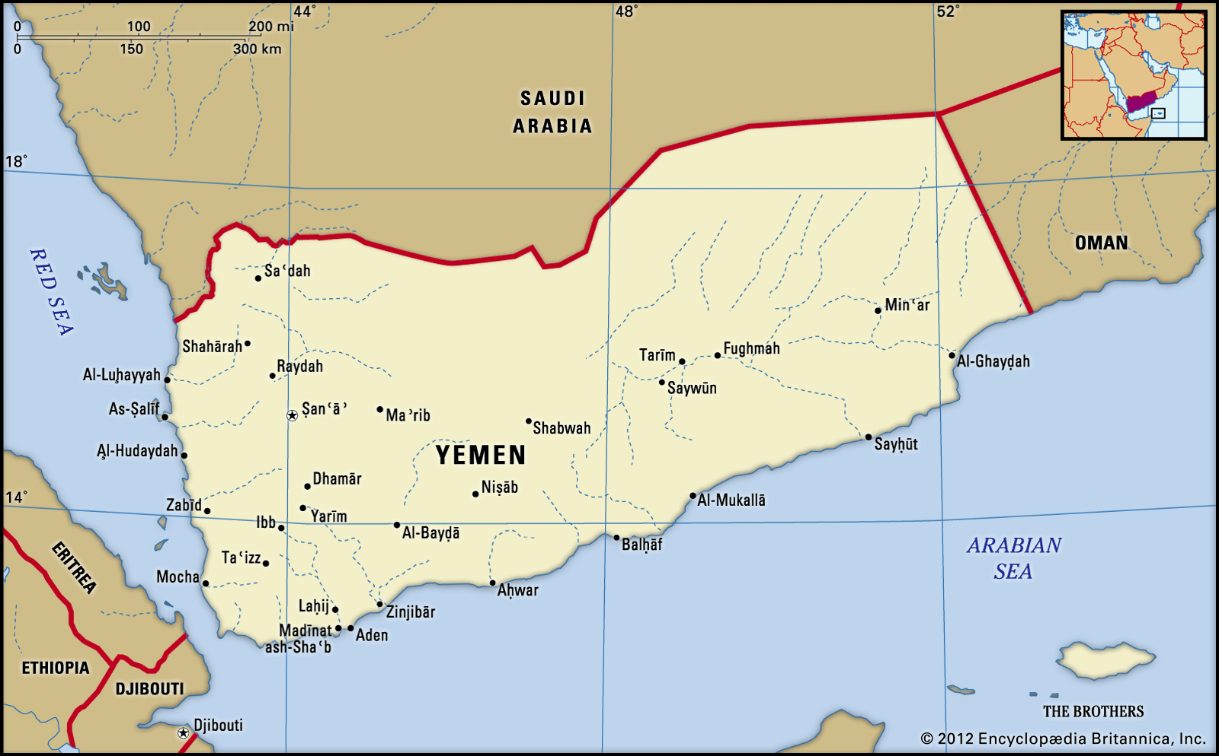
Introduction
Yemen is a country situated in the Arab peninsula which has been torn by a civil war developing since 2015 that has affected all citizens of the country but mostly, Yemeni children. Yemen has one of the highest infant mortality and malnutrition rates in the entire world. This is mainly because of the previously mentioned war and this isn’t the only way in which this war has affected yemeni society. Lack of hygiene is the main factor contributing to the high mortality in the country. In Yemen, a simple cold or a little cut could be deadly because of infections and lack of medical supplies.
Graph taken from https://www.unicef.org/emergencies/yemen-crisis
As poverty levels have risen, child labour has become frequent. 23% of children between 5 and 14 years old are forced into an environment of sexual exploitation and even slave treatment. Child abuse within families, including constant rapings is also common. To escape these situations, children often run away and find themselves alone and without shelter.

These abuses have led to an increase in child trafficking, not only for turning them into sex slaves or organ trafficking, but also for forced child marriage. More than 30% of young girls are pregnant by 15, married before the age of 18 and suffer marital violence.

Poverty has also interfered with the right to an identity. Nearly 80% of Yemeni children do not have one, seeing as most births are not officially declared to public authorities, partly from the costs of registering. These facts don’t seem to bother Yemeni adults because children don’t have any particular legislative protection so these situations are common and not worthy of fixing.

All things mentioned before influence directly in education. Establishments are extremely unhealthy (often there are no bathrooms or recreational areas), the presence of armed forces in the country makes travel to school difficult and dangerous and parents often want their children to work, not study.

Definition of Key Terms
Malnutrition
The World Health Organization (WHO) defined malnutrition as “deficiencies, excesses or imbalances in a person’s intake of energy and/or nutrients” It also adds that “the term malnutrition covers 2 broad groups of conditions: ‘undernutrition’—which includes stunting (low height for age), wasting (low weight for height), underweight (low weight for age) and micronutrient deficiencies or insufficiencies (a lack of important vitamins and minerals) and overweight, obesity and diet-related noncommunicable diseases”.
Child Labour
According to the International Labour Organization (ILO) “The term “child labour” is often defined as work that deprives children of their childhood, their potential and their dignity, and that is harmful to physical and mental development.”
Human trafficking
US federal law in 2000 defined trafficking as “the recruitment, harboring, transportation, provision, or obtaining of a person for labor or services, through the use of force, fraud, or coercion for the purpose of subjection to involuntary servitude, peonage, debt bondage, or slavery.”

Issue Overview
Historical Background
Government And Society
When North Yemen and South Yemen existed, they had political systems that heavily collided. North Yemen was a republic with a 1970 constitution (suspended in 1974 and restored between 1978 and 1980). Between those years, policies were made by a military government that worked closely with civilians while South Yemen had a Marxist regime, although also being a republic.

In 1990 a unified political system was created that presented a huge change from both previous systems. It also enabled the establishment of a multiparty representative democracy.
Civil war
This war started after the unsuccessful attempt to change the political status of the country following an uprising that forced longtime authoritarian president, Ali Abdullah Saleh, to hand over power to his deputy, Abdrabbuh Mansour Hadi, in 2011. As president, Hadi struggled to handle problems such as attacks by jihadists, (a movement in south Yemen), corruption, unemployment and food insecurity.

The Houthi movement, who defended Shia muslim minorities in Yemen, took advantage of the new president's weakness and took control of their northern heartland of Saada province and neighbouring areas. Many people, including Sunni muslims, supported the Houthis on their movement to take the power. The Houthi Movement, together with Saleh’s loyals, attempted to take control of the entire country, forcing Hadi to flee in March 2015.
How is the crisis affecting children?
Children are killed and maimed in the conflict. Approximately 360,000 children under 5 years old suffer from severe malnutrition and require treatments. The damage and closure of schools and hospitals disrupted their access to education and health services, leaving them even more vulnerable and robbing them of their futures. In September 2019, when the new scholar year started, 2 million kids stopped attending and, as the year progressed, another half million of kids left school.

Major Countries and Organizations Involved
- UNICEF: This organization considers the situation in Yemen to be ‘the largest humanitarian crisis in the world’. They continuously provide essential food and medical supplies. In addition, nearly 9 million people across Yemen had been aided with emergency cash assistance by UNICEF to help them meet their urgent needs by July 2019. UNICEF and partners are als rehabilitating damaged schools and establishing safe locations to learn.
- International Committee of the Red Cross: The ICRC has many teams in Yemen that not only provide food, water, health care and basic household needs such as blankets, but also contribute to improve and rebuild the installations destroyed because of the conflict.
- US: President Biden has recently announced a drastic change in the approach to the Yemen conflict. All aid to the Saudi-led allies has been removed, and the United States will cease its support to any offensive operations, such as but not limited to the sale of arms to Saudi Arabia and the United Arab Emirates.
- Iran: Iran has supported the Houthi rebel movement with armament and money.
- Saudi Arabia: President Hadi called for military support from Saudi Arabia, after he had to leave Yemen because of the Houthi Movement. Therefore, in 2015 the Saudi-led allies launched a series of attacks on the country. Saudi Arabia continues to be an ally to the President and his forces.

Latest Events
The Riyadh agreement (5th November)
Yemen's internationally recognised government and United Arab Emirates (UAE)-backed separatists have signed a power-sharing deal to halt infighting. Saudi Crown Prince Mohammed bin Salman announced the agreement between the Yemeni government and southern separatists to end a power struggle in the war-torn country's south.
UNICEF alarm
The United Nations children's agency (UNICEF) has sounded the alarm over the dangers faced by children in war-torn Yemen, calling for an immediate end to a long-running conflict that has triggered the world's worst humanitarian crisis.
Possible Solutions
The conflict in Yemen is progressively getting worse, meaning that the situation of those unsheltered children is of utmost concern. What should be done is to encourage those previously mentioned Member States and organizations to keep on providing aid. Furthermore, other NGOs and countries should be stimulated to participate in the projects that aim to improve Yemeni children’s education and life quality or create new projects of their own.
In order to solve this issue completely, the adult population must be reformed into valuing children and respecting their rights. That is why it is necessary to create projects to educate those ignorant adults about what the United Nations' 1989 Convention on the Rights of the Child implies in order to raise awareness of the current committed crimes and pressure the Yemeni government to enforce child protective laws.

Useful reference material
Human Rights Watch(2018), Yemen events of 2018, https://www.hrw.org/world-report/2019/country-chapters/yemen
The World Factbook MIDDLE EAST :: YEMEN 2020. Washington, DC: Central Intelligence Agency, https://www.cia.gov/library/publications/the-world-factbook/geos/ym.html, 07/02/2020
UNICEF, Yemen Country Office Humanitarian Situation Report, https://www.unicef.org/appeals/files/UNICEF_Yemen_Situation_Report_Year_End_2019.pdf, 31/12/2019
United Nations Human Rights,Convention on the Rights of the Child, https://www.ohchr.org/en/professionalinterest/pages/crc.aspx, 18/11/2002
Bibliography
Humanium, Children of Yemen, realizing children’s rights in Yemen; https://www.humanium.org/en/yemen/; 06/02/2020
Freedom united, Definition of Human Trafficking; https://www.freedomunited.org/news/definition-of-human-trafficking/?gclid=CjwKCAiAj-_xBRBjEiwAmRbqYgjqIbIcWIGY--hNDrCkQgj_tyyjf1cTppZDEbyPypuzuKeMglaF3RoCa0cQAvD_BwE; 26/10/2015
Snyder, S.; Here's how you can send help to people surviving in the world's worst humanitarian crisis; https://www.pri.org/stories/2017-11-29/heres-how-you-can-send-help-people-trapped-worlds-worst-humanitarian-crisis; 14/12/2018
World Health Organization, Thalassaemia patients have renewed hope through support provided by the Emergency Health and Nutrition Project; http://www.emro.who.int/yem/yemen-news/thalassemia-patients-have-renewed-hope-through-support-provided-by-the-emergency-health-and-nutrition-project-ehnp.html; 05/11/2019
Wenner, M. W., & Burrowes, R.; Yemen https://www.britannica.com/place/Yemen; 9/12/2019
UNICEF, Yemen cisis; https://www.unicef.org/emergencies/yemen-crisis; 06/02/2020
BBC, Yemen crisis: why is there a war?; https://www.bbc.com/news/world-middle-east-29319423; 21/03/2019

