Forum: Security Council
Issue: The issue of the surge of new Israeli settlements
Student Officer: Ekaterina Korabelnikova
Position: Deputy President

Introduction
Over the past six decades, the constant tensions between the Jewish and Arab population of Israel and Palestine have been the primary cause of what is known today as Israeli settlements. What first started as a fringe group of motivated civilians has turned into an institutionalized part of Israeli society. Almost a tenth of the Israeli population populate the West Bank outside of their country’s recognized, sovereign territory. Even though parts of the West Bank is known to fall under Palestinian territory, settlers have inhabited this land due to religious and war claims to it after the 1967 Middle East War. Over time, it has gotten even more difficult to separate the Israeli settlements from the Palestine villages, as the two have merged into one intricate system.
Past actions with the goals of resolving this issue have been counterproductive and have failed to produce a viable solution. The question of sovereignty arises, as the majority of the international community, including the International Court of Justice and the UN, have recognized such settlements as illegal, due to the fact that the territory does not belong to them.
The current situation concerning the surge of new Israeli settlements is unsustainable, as communities continue to live in the prolonged rising tensions, their basic human rights continue being ignored by their leaders due to national security, while Israel continues to build and furtherly develop their settlements despite the pressure from international actors. The United Nations Security Council must come together once and for all to multilaterally and cooperatively to develop a solution that guarantees the rights of said citizens, allows both the Israelis and Palestinians to come to an agreement, and to establish peace in this region.

Definition of Key Terms

West Bank
The West Bank is a landlocked territory located on the coast of Western Asia near the Mediterranean sea and east of Israel. This chunk of land has played a paramount role in the development of the conflict between Israel and Palestine. It is populated by an approximate amount of three million Palestinians and is the largest territory of the nation, as divided by the Oslo Accords. However, Israel holds great historical and religious significance to the region, hence the reason behind the surge of Israeli settlements

Israeli Settlements
Israeli settlements are defined as the civilian communities of Jews who have migrated to the West Bank from Israel after the Six-Day War in 1967. They act as an impediment to peace due to the violation of international law.

Gaza Strip
The Gaza Strip is a territory along the Mediterranean strip which shares a border with Israel and Egypt. It is one of the most densely populated and isolated areas in the world, facing a severe humanitarian crisis due to it being under a multilateral maritime and terrestrial blockade.
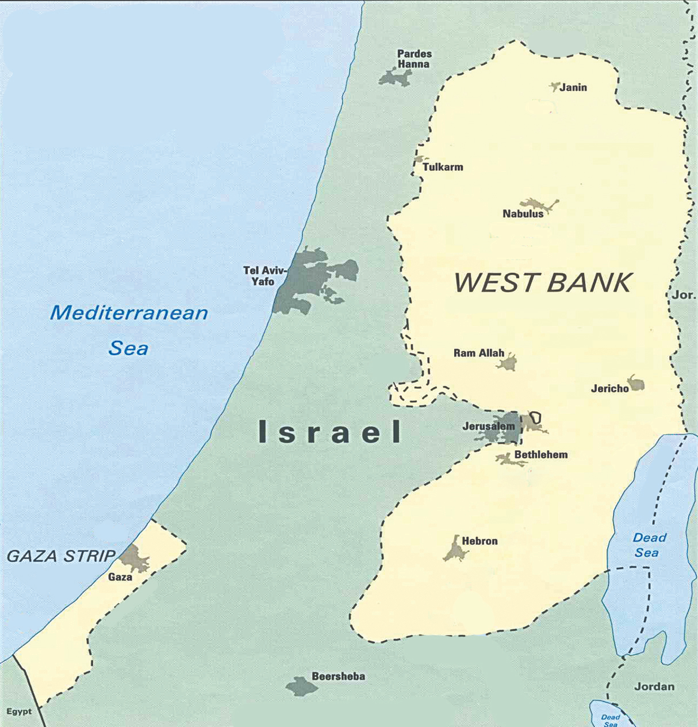
Map showing the West Bank and the Gaza Strip

Zionism
Zionism is known as Israel’s national-political ideology. This belief originated in the 17th century and involves the idea of Judaism being considered both a religion and a nationality, hence the reason why Jews deserve their own state in their ancestral homeland of Israel (current Palestine lands).

Antisemitism
The prejudice and hostility against Jewish people.

Hamas
Hamas is a political party and Palestinian Islamist militant group that has won elections in 2006. It has continued to acquire power, specifically in the Gaza Strip. However, it is recognized as a terrorist organization by numerous nation-states such as the European Union and the United States.

Annexation
The formal act of a state to proclaim its power and sovereignty over territory outside of its rule.

One-State solution
This solution regards the idea of merging Israel, the Gaza Strip, and the West Bank into one central nation.

Two-state solution
This solution follows the idea of allowing Israel and Palestine to be their own sovereign states. Each nation would have full autonomy over their nation and territory, however, due to this solution the challenge of deciding borders arises.

Issue Overview
The prolonged conflict between Israel and Palestine has lasted for over six decades and has led to the increase of tensions, the violation of basic human rights, and the challenge of disputed territories among both nations.

Historical Background
Back in 1948 the current territories of the West Bank and Israel were mandated and controlled by Great Britain. Due to the growing tensions between the Jews (Israel) and the Arabs (Palestine), Great Britain worked with the UN to split the land into two states. The Jews accepted this plan and declared independence as the State of Israel. However, the Arabs saw this plan as the continuation of European colonialism, thus declaring war on Israel. Israel emerged from the war victorious and pushed past the borders of the UN plan. No borders were created, instead, a ceasefire was created and the West Bank was given to Jordan.
This fragile ceasefire remained until 1967 when Israel fought another war with its Arab neighbours. This war known as the Six-Day War resulted in Israel gaining an immense amount of land, including the West Bank which had great religious significance due to the hills of the ancient Judea and Samaria. During that time Israel had to make a choice between giving the West Bank back to Jordan, annexing it, or letting its people create a new sovereign state. During the time that it took the government to come to a decision, Isreal citizens began to move into the West Bank and establish a Jewish presence. This can be viewed as Jewish civilians moving to mainly empty plots of land which they fairly captured during the war due to their historical significance to them. Or it can be seen as settlers colonizing land to gain power and authority. In response to this, violent protests against these settlements surged in Palestine as the international community including the UN did not approve of such settlements. Despite international condemnation, the number of Israeli settlers grew at an alarming rate, as Israeli politicians began to support the settler movement and allocate public resources and granting permits for building.
In the mid-1990s the US president Bill Clinton, Israeli Prime Minister Yutzhak Rabin, and Palestinian leader Yasser Arafat signed the Oslo agreement which established the Palestinian government and split the West Bank into 3 sections. Area A covered 18% of the land and was given full control and sovereignty to the Palestinian government. Area B covered 22% of the land and was given to the Palestinian government control but including Israeli security control. Lastly, area C which contains 60% of the West Bank was given to the full control and authority of Israel.
In 2005, Israeli Prime Minister Ariel Sharon decided to remove and forcefully resettle 8,500 settlers from the Gaza Strip. This left a catastrophic impact on the nation’s population and caused the numbers of Israeli settlers in the West Bank to continue to grow.
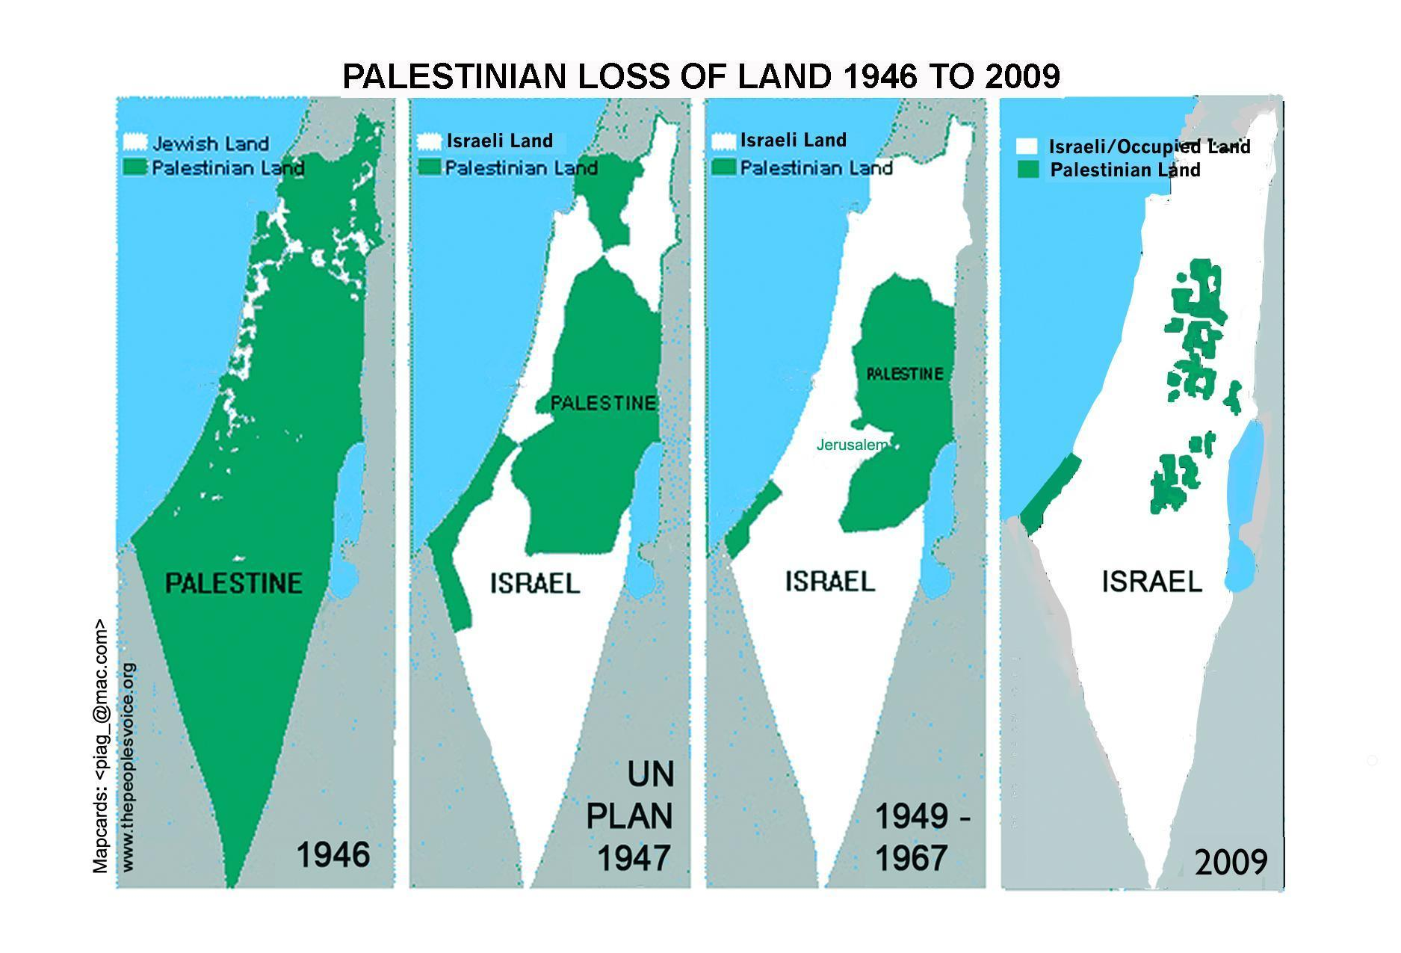
Palestinian loss of land from 1946 to 2009

Timeline of Events
Date Description of event
1948 The UN and Britain suggest the split of Palestine into two separate nations. Israel declares independence, however Arab armies (Palestine) declare war on Israel.

1967 The Six-Day War led to a massive intake of land for Israel. They occupied East Jerusalem, the Gaza Strip, the West Bank, Sinai, and Golan Heights. This was the beginning of the Israeli settlements

1968 The United Nations Security Council adopts Resolution 252 regarding the invalidity of military acquisition of territory (centred on the rise of Israeli settlements)

1993 Oslo Accords signed.

2000 - ongoing Barriers and checkpoints between Israeli settlements and Palestine towns are built.

2003 The Road Map to Peace Plan, proposed by the United States between Israel and Palestine is signed.

2008-2009 War in the Gaza Strip.

2015 Israeli Prime Minister claims Jerusalem as the capital of Israel.

Settlement demographics
There are currently over 500,000 Jewish settlers living in the 132 scattered settlements and 113 outposts (settlements built without authorization) in the West Bank. Solely in East Jerusalem, there are 13 settlements that are inhabited by approximately 215,000 settlers. These settlements can range from
It is estimated that almost a tenth of Israeli Jews reside in the region of the West Bank and in east Jerusalem. According to Israel’s Central Bureau of Statistics, the population of settlers in the West Bank has grown at four times the rate of Israel itself since 1995. Even though settlements occupy only 2% of the land in the West Bank, they hold control over 42% of the territory. The settlements range from simple communities to industrialized and organized communities having their own secondary and higher education facilities.
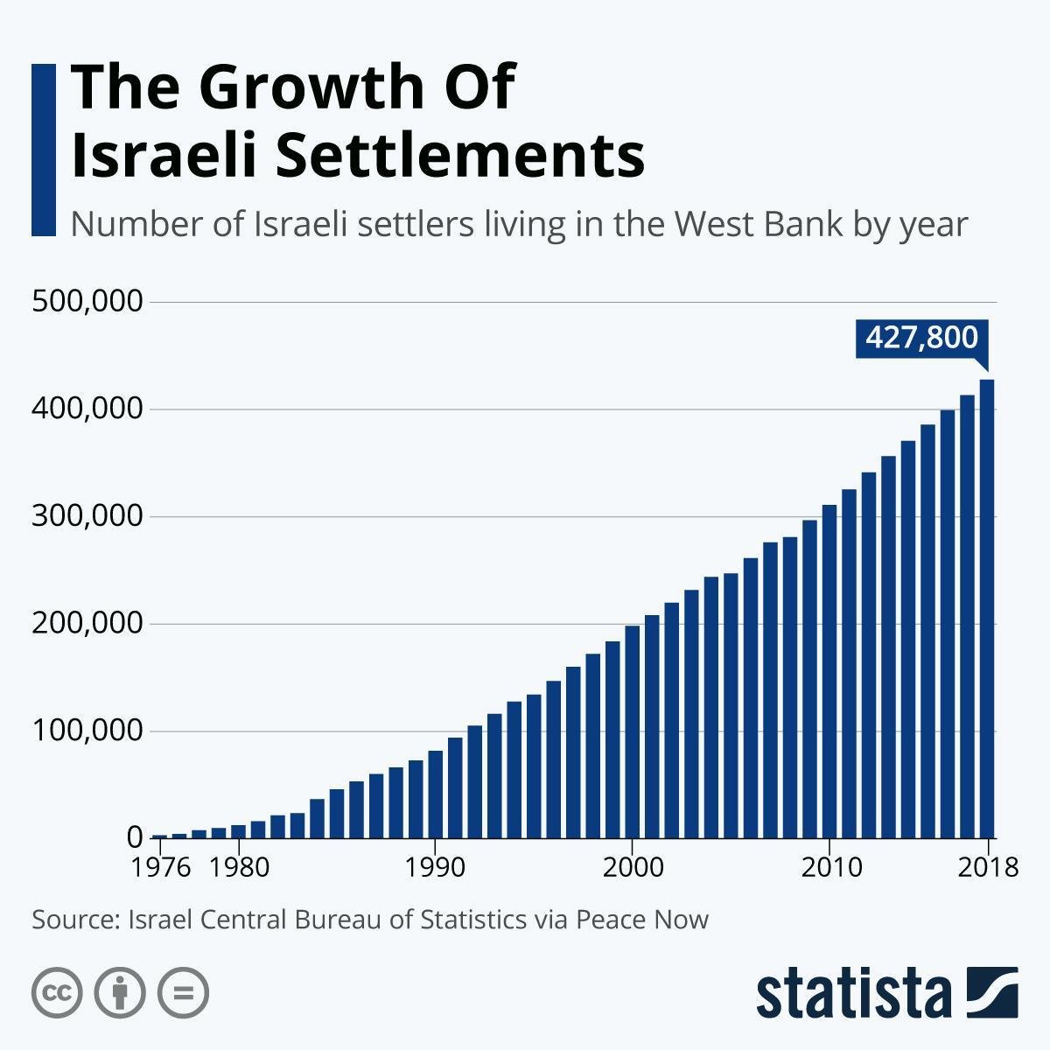
Graph showing the growth of Israelis living in settlements

Current situation
Ever since the late 2000s, Israel and Palestine have attempted to establish peace between the nations, however, the tensions between the two states have not allowed them to be successful. In 2012 Palestine was given de facto recognition as a sovereign state from the United Nations, as they were given the right to become a non-member observer state in the institution.

Why settlements continue being disputed
Palestinians argue that the increase of such settlements and Israel’s annexation of both the settlements and Jerusalem challenge the peace between the two nations. As they prevent the development and establishment of a fully sovereign Palestinian state. This is mainly due to the lack of territorial contiguity which prevents the Palestinian leaders to develop infrastructure and the movement of both people and public goods.
In addition to that, the majority of the international community including the UN deem such settlements as illegitimate due to the fact that they violate international law. The UN Security Council, the UN General Assembly, the International Committee of the Red Cross, the International Court of Justice, and the High Contracting Parties have spoken out on the violation of Article 49 of the Fourth Geneva Convention, including UN Security Council resolutions in 1979, 1980, and 2016. On the other hand, Israel has stated that the Fourth Geneva Convention does not apply de jure to the West Bank as the territory is not officially occupied by a legitimate sovereign state.

Economic impacts
Studies and reports reveal that the occupation of the West Bank by Israeli Settlements deprive the Palestinian community of their human right to development, as stated in the UN Declaration of Human Rights. This includes the confiscation of Palestinian land, natural resources, restrictions on the movement of goods and people, destruction of assets, fragmentation of domestic markets, and other consequences which prevent the development of the Palestinian economy. From 1975-2014, Palestine’s share of its tradable goods sector (which includes the nation's production of agricultural and industrial products) in GDP dropped from 37% to 18% and its contribution to employment decreased from 47% to 23%.

Major Countries and Organizations Involved
- State of Israel: The State of Israel established its independence in 1948 by the UN and Great Britain and is the world’s only Jewish state. Its government has supervised and endorsed the construction and development of new settlements. The nation has provided both financial and religious motives to its citizens, endorsing the construction of such settlements. Since 1967, when the first settlement was constructed, the government has sanctioned a total of 132 settlements in the West Bank. Recently in January 2021, the Israeli government has approved 780 additional homes built in the West Bank settlements.
The Israeli Zionist movement has endorsed and motivated Israeli citizens to build settlements in the West Bank, as the occupation of land in the West Bank held a great religious and historical significance of reclaiming the Holy Lands and fulfilling their religious purpose. Despite facing international and national criticism, Israel’s prime minister Benjamin Netanyahu has led his political campaign revolving around the promise of the annexation of the West Bank.
- Palestine: Tensions between Palestine and Israel have been present in both nations since the mid-1900s. Over that period of time, Palestinian citizens have been forced to live in or near settlement territory and have reported violent incidents on behalf of the Israeli citizens. In addition to that, Israeli settlements severely limit the urban development of Palestinian towns and cities, prevents their economy from growing, and limits the movement of Palestinians. Many activist groups and politicians have spoken about the limitations for a contiguous and sovereign Palestinian State due to the rise of Israeli settlements.
The leaders of Palestine have spoken and called on the international community to act against the State of Israel due to the illegitimacy of the built settlements, however, such calls were ignored. It is important to note that not all nations have recognized the sovereignty and independence of Palestine, however, it is a non-member observer state in the United Nations.
- United States of America: The United States of America and Israel have had strong diplomatic relations since the independence of the State of Israel, due to their strong economic ties and mutual interests. The US continues to be present and involved in the Peace Process negotiations between Palestine and Israel, however, their goal is to preserve national security in Israel and does not have any diplomatic relations with Palestine as they do not recognize them as an official state and recognize the Hamas, the Palestinian government in the Gaza Strip, a terrorist group.
- Arab League: The Arab League is a regional intergovernmental organization that is composed of nations in and around North Africa, Arabia, and the Horn of Africa. This organization has been active and present in trying to resolve tensions between Palestine and Israel. This organization condemns the US’s tolerance and acceptance of the Israeli settlements and claims them to be illegitimate.

Previous Attempts to Solve the Issue
There have been numerous previous attempts to solve the issue at hand, however, all have been unsuccessful and have not established peace in the region. As stated previously there have been numerous Security Council resolutions passed regarding the protection of civilians during war times, the reaffirmation of Israeli settlements constituting an obstruction for peace in the region, reaffirming that Israeli settlements are illegitimate and illegal according to international law, however, Israel continues to abuse their power and build settlements in the West Bank and the territory surrounding that region.
The Oslo Accords were a momentous moment in the pursuit of peace in the Middle East region among Israel and Palestine. They are a document of agreements between the Palestine Liberation Organization (PLO) and the Government of Israel. They are a peace treaty based on the UNSC Resolutions 242 and 338 which were created to fulfil the purpose of establishing the right of Palestinians to self-determination. This treaty created a Palestinian Authority and gave control of land in the West Bank, it is important to note that the Oslo Accords did not create a Palestinian state. Despite both of the sides in the bilateral agreement to actively pursue peace between the nations, this treaty failed to resolve major issues such as the Palestinian right of return, status of Jerusalem, and the state of Israeli settlements.
Later on, in 2003, the Quartet on the Middle East made up of the United Nations, European Union, USA, and Russia created an initiative called the Roadmap For Peace which was signed by both Israel and Palestine. This roadmap created a plan for a two-state solution, however, it was unsuccessful due to some of the Israeli reservations.
Possible Solutions
It is essential for Israel and Palestine to bilaterally come to an agreement with the goal of establishing peace in this region. Some scenarios we ask you to bear in mind is the two-state solution which contains the recognition of both Israel and Palestine as two independent states. In this solution boundaries and territories must be established which is difficult due to a large number of Israeli settlements present in or near Palestine cities and villages. Even though this solution is said to be most favoured, it has been presented multiple times with no success, due to the lack of cooperation and agreement form Israel and the United States. As well as the one-state solution which proposes the idea of a united Israeli-Palestinian state with its own government. This newly formed nation would hold power and sovereignty over Israel, Palestine, the West Bank, and Gaza. When resolving the issue of Israeli settlements it is vital to acknowledge the historical political conflict between the two states in the region, as well as the interdependent nature of the conflict.
Some other possible solutions regarding the issue are to suggest the State of Israel to create multicultural communities within the West Bank, made up for both Muslim and Jewish communities. Even though this solution does not fix the problem of Israeli settlements it contributes to the social union of the citizens in that region, which is vital for the establishment of peace. It is important to take into consideration that this solution carries a great risk of tensions and violence between the two communities due to the ideological and cultural gap.
Another possible solution is to propose a land-swap between Israel and Palestine. Although this will be very complex and intricate, it would allow Israeli citizens to regain the religiously significant land in the West Bank and allows Palestine to have control over their own land. As stated previously this is a highly complicated procedure, however, if carried out with detail and organization it can lead to great success.
Useful reference material
- Fourth Geneva Convention, 12 August 1949
- Security Council Resolution, 22 November 1967 (SCR/242)
- Security Council Resolution, 22 March 1979 (SCR/446)
- Security Council Resolution, 7 October 2000 (SCR/1322)
- ICJ Advisory Opinion, 9 July 2004
- Security Council Resolution, 23 December 2016 (SCR/2334)
- General Assembly Resolution, 7 December 2017 (A/RES/72/86)
Bibliography
Everything you need to know about human rights in Israel and Occupied Palestinian territories. (n.d.). Retrieved March 16, 2021, from https://www.amnesty.org/en/countries/middle-east-and-north-africa/israel-and-occupied-palestinian-territories/report-israel-and-occupied-palestinian-territories/
Israel and the Palestinians: Can the settlement issue be solved? (2019, November 18). Retrieved March 16, 2021, from https://www.bbc.com/news/world-middle-east-38458884
Israeli settlement. (n.d.). Retrieved March 16, 2021, from https://www.britannica.com/place/Israeli-settlement
Levingston, I. (2020, January 30). Israeli Settlements. Retrieved March 16, 2021, from https://www.bloomberg.com/quicktake/israeli-settlements
Locke, S. (2018, November 20). Everything you need to know about Israel-Palestine. Retrieved March 16, 2021, from https://www.vox.com/2018/11/20/18079996/israel-palestine-conflict-guide-explainer
Voxdotcom (Director). (2016, September 19). Israeli settlements, explained | Settlements Part I [Video file]. Retrieved March 16, 2021, from https://www.youtube.com/watch?v=E0uLbeQlwjw
Appendix
- Comprehensive guide to understand the Israeli-Palestine conflict and the rise of Israeli settlements: https://www.vox.com/2018/11/20/18079996/israel-palestine-conflict-guide-explainer
- UN press release regarding the current state of Israeli settlements: https://www.un.org/press/en/2020/sc14085.doc.htm
- https://www.youtube.com/watch?v=E0uLbeQlwjw

Tzemah, E. (2019, May 21). [Map of Israel and the West Bank]. Retrieved from https://blogs.timesofisrael.com/israels-right-to-the-west-bank/
Entous, A. (2018, July 9). [Map of Israeli Settlements]. Retrieved from https://www.newyorker.com/news/news-desk/the-map-of-israeli-settlements-that-shocked-barack-obama
McCarthy, N. (2020, June 30). The Growth of Israeli Settlements [Digital image]. Retrieved from https://www.statista.com/chart/20001/number-of-israeli-settlers-living-in-the-west-bank-by-year/

